# Track a Cohort: Winter-Run Figures

Figure 1. abundance (JPE plot)- Brian

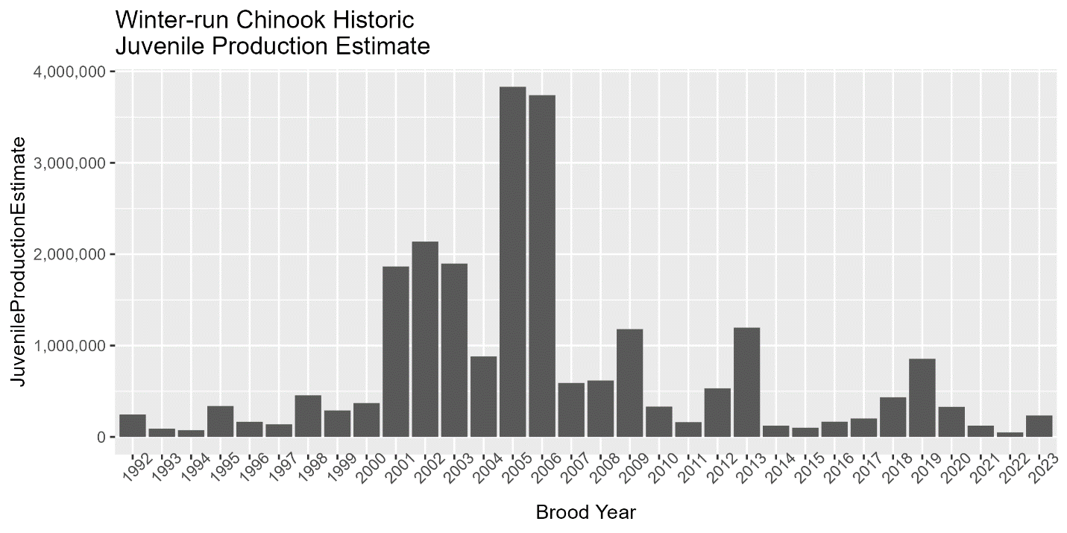

Figure 2. survival (STARS plots) - Chase

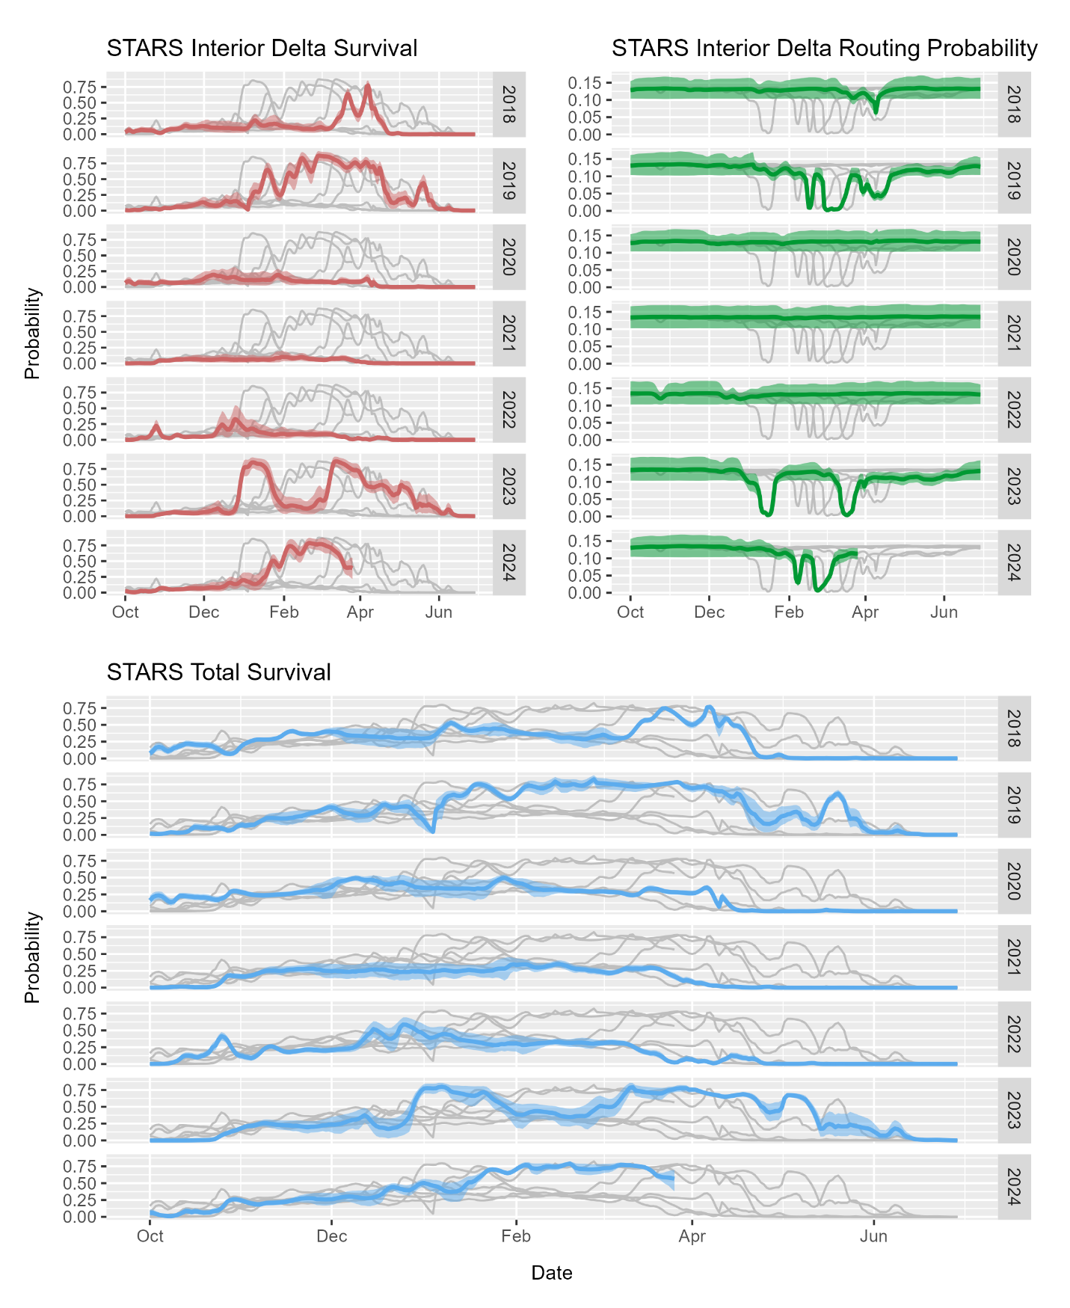

Figure 3. minimization (% of the JPE, (1) bar plots of totals, (2) annual cumulative loss by period and water year type) -Chase, and Nick

Figure 4. minimization (LAD loss , genetic loss)-  Chase

Figure 5.

Figure 6.

Figure 5. minimization (% of hatchery fish loss)

* CWT page on SacPAS

Figure 7. minimization (Tillotson output- predicted loss)- Chase

